1. Concrete Pavement
   1. Dielectric

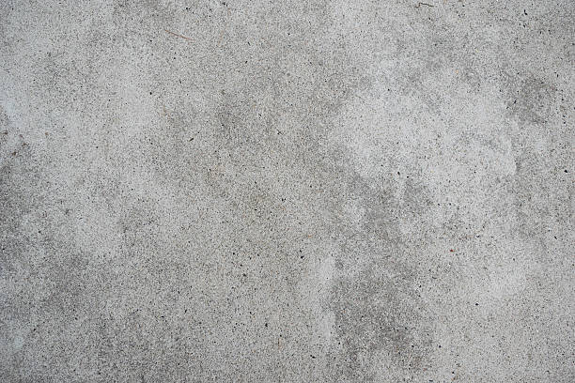

1. Marble
   1. Dielectric

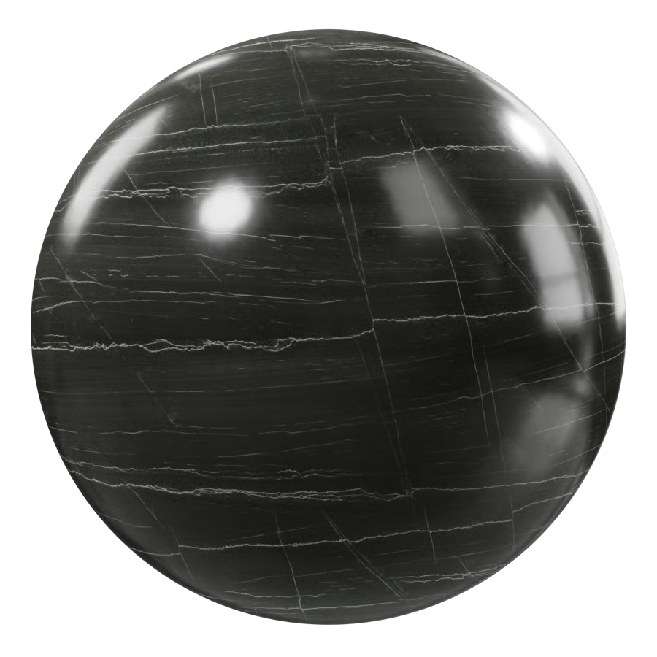

1. Rusted Iron
   1. Metallic

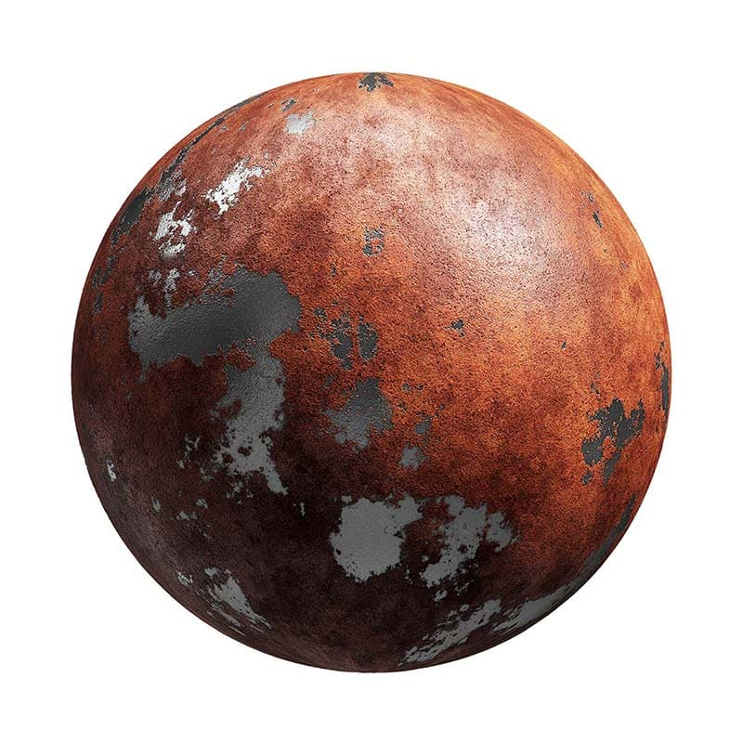

1. Glazed tile floor
   1. Dielectric

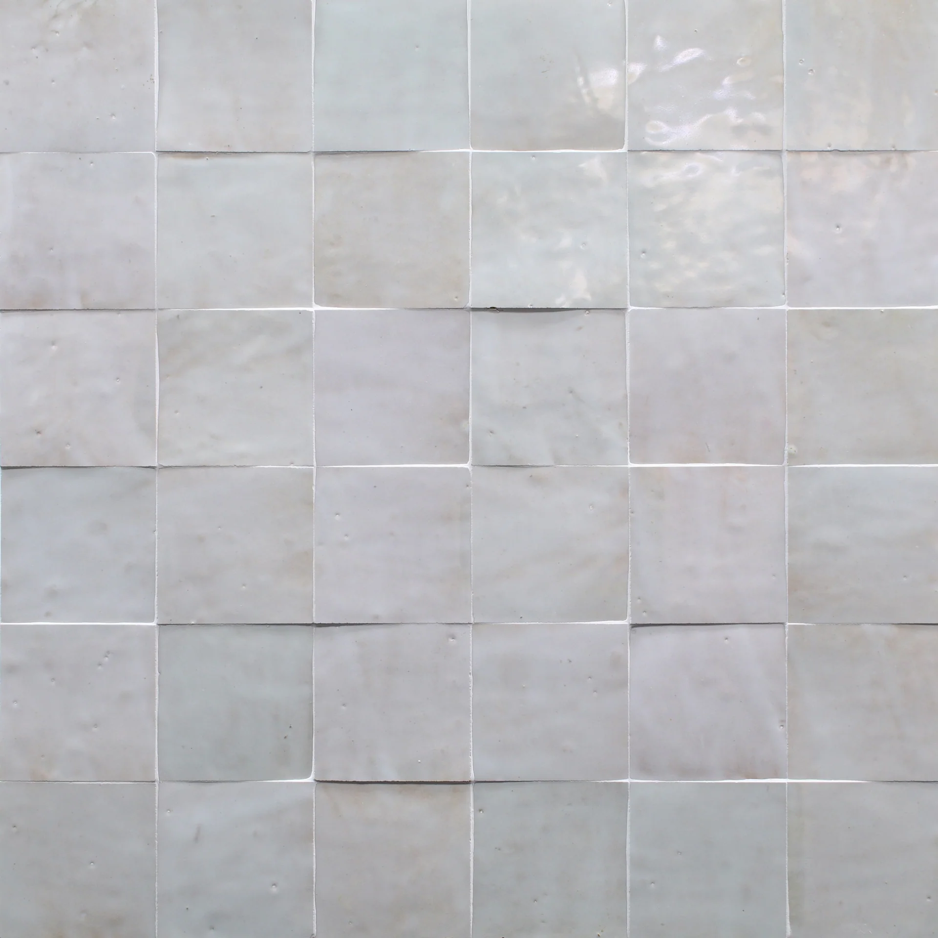

1. Wax
   1. Dielectric

